Here is a step by step guide explaining how to compile and run he code

1. Extract the zip folder I sent
2. Copy checksum file in the extracted folder
3. Paste the checksum.java file you copied in the previous step and paste in in the CIS3360-Hw2-rls02.1 you sent earlier.
This CIS3360-Hw2-rls02.1 is the one that contains the test files

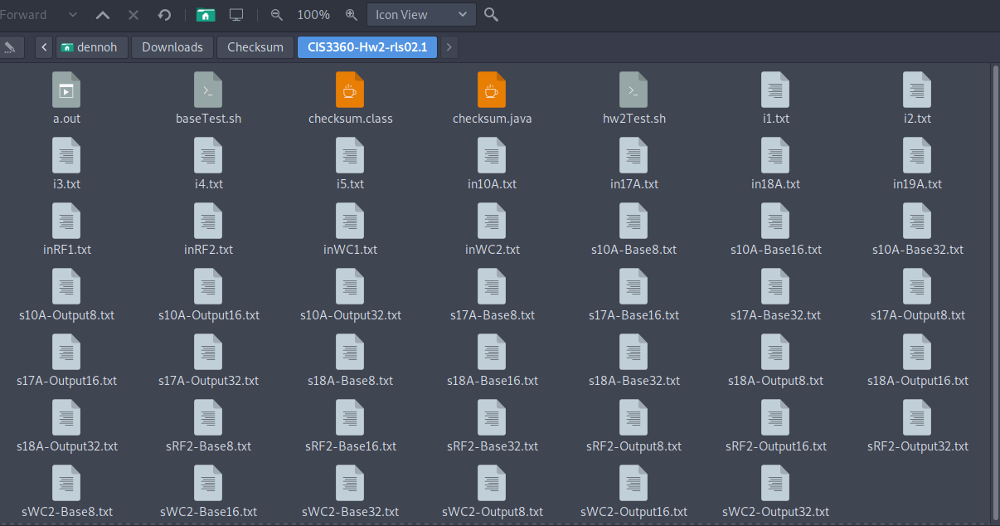

4. run this command on your command prompt to create an executable file of your .java file:
javac checksum.java

if you get an error here saying javac is not installed you can go ahead and install an appropriate java jdk on your windows pc say jdk8 and then repeat step 4
5. after that you can go ahead and run this command or as shown on the screenshots that I sent earlier.

java checksum.java i1.txt 8

where checksum.java .txt is the input file
and 8 is the bit size which can be either 8, 16 or 32

Repeat step 5 for all the test cases given in the CIS3360-Hw2-rls02.1 folder
6. You can also go ahead and test you code further by:
Making making the *.sh file in this folder CIS3360-Hw2-rls02.1 by just running

bash baseTest.sh

bash hw2Test.sh

